Project Report Automatization
  - Transforming Unstructured Reports into Actionable Insights
Implementation plan

Jan Bartyzal
2. 3.2026 version:1.2
Contents
Executive Summary 3
Assignment 3
Azure Infrastructure Design 3
Compute and Orchestration 3
Data Persistence 4
Security and Networking 4
AI Services 4
Target architecture 5
Cost estimate 6
Roadmap 7
Phase 0 – Generali & GOSP approval (M0) 7
Phase 1 – MVP: End-to-End ingestion (M1–2) 7
Phase 2 – Intelligence & visualization (M3–4) 7
Phase 3 – Reporting lifecycle (M5–6) 7
Phase 4 – Report generation & production hardening (M7–8) 8
Phase 5 – Rollout & optimization (M9–10) 8
Phase 6 – Local scope & advanced analytics (M11+) 8
Implementation plan 9
Phase 1 – MVP Core 9
Phase 2 – Extended parsing 10
Phase 3 – Intelligence & admin 11
Phase 3b – Reporting lifecycle 12
Phase 3c – Form builder 13
Phase 4 – Enterprise features 14
Phase 4b – PPTX report generation 15
Phase 5 – DevOps maturity 16
Phase 6 – Local scope & advanced analytics 17
Summary 18
Estimation Methodology and Assumptions 18
Conclusion 19
Final architecture 20
Ingestion & Processing Flow 21
Auth & RBAC Flow 21
Data Persistence & Read Model (CQRS) 22

Executive Summary
The project aims to transform the holding company's financial reporting from a manual, error-prone process to a fully automated data platform. By implementing technology for extracting data from unstructured files (PPTX, Excel), we eliminate 90% of manual work, increase data accuracy, and reduce consolidation time from days to minutes.

Assignment
The platform covers the OPEX reporting lifecycle from subsidiary-level data entry to centralized reporting. Users upload Excel files that serve as a sub-database for generating PPTX reports according to a unified template. This data simultaneously feeds centralized reporting without the need to import and combine individual PPTX files. The platform supports two data ingestion modes: file upload (Excel) and a centralized web form for structured data collection. Reports go through a status confirmation workflow before acceptance into central reporting. The architecture is microservice-based, enabling incremental delivery and future module expansion

Azure Infrastructure Design
The proposed solution is built on the Event-Driven Architecture pattern, implemented natively on Microsoft Azure. All platform components run as containerized microservices in Azure Container Apps (ACA), with inter-service communication and state management abstracted through Dapr sidecars. This eliminates infrastructure boilerplate from application code and enables consistent patterns for pub/sub messaging, service invocation, and secret retrieval across all 31 microservices.

Compute and Orchestration
The core application workload runs on Azure Container Apps (ACA) with a Consumption Plan, providing automatic scale-to-zero for stateless services and cost-efficient scaling for bursty workloads such as file parsing. Each Atomizer service (PPTX, Excel, PDF, CSV, PPTX Generator) scales independently based on queue depth – a CPU-intensive OCR job does not affect the responsiveness of the API Gateway or the Form Builder.
The N8N Orchestrator runs as a persistent container with a dedicated minimum replica count of 1 to ensure webhook availability. All N8N workflows are version-controlled as JSON files in Git, enabling reproducible deployments and code-reviewed changes to business logic without touching application code.
The React Frontend is deployed as a static bundle to Azure Static Web Apps, which provides built-in global CDN distribution, automatic SSL, and native integration with Azure Entra ID for authentication. This separates frontend delivery from the backend compute layer entirely.
Dapr is enabled at the ACA environment level, providing each service with a sidecar for service-to-service invocation, pub/sub messaging (used for the report.status_changed lifecycle events consumed by N8N), and distributed tracing propagation without additional SDK dependencies.

Data Persistence
Azure Database for PostgreSQL – Flexible Server serves as the primary data store for all structured data: extracted tables, form responses, report metadata, audit logs, version history, and schema mapping definitions. PostgreSQL is also used for vector embeddings via the pgVector extension, eliminating the need for a separate vector database. Row-Level Security policies are defined at the database engine level, ensuring tenant data isolation is enforced regardless of application-layer behavior. Flyway manages all schema migrations, guaranteeing consistent schema state across development, staging, and production environments.
Azure Blob Storage holds all binary artifacts: uploaded source files (PPTX, Excel, PDF), intermediate processing artifacts (slide images, temporary CSVs), and generated output reports (PPTX). Atomizers never pass binary data as inline payloads – they read from and write to Blob Storage directly, exchanging only URLs through N8N. A lifecycle policy on the Blob container enforces automatic deletion of temporary artifacts after 24 hours, enforced additionally by the MS-ATM-CLN cleanup worker.
Azure Cache for Redis provides two distinct functions: a query result cache for the CQRS read layer (MS-QRY, TTL-based invalidation), and a Dapr State Store backend used for distributed rate limiting counters and session token management.

Security and Networking
All inbound internet traffic passes through Azure Application Gateway with WAF v2, which provides DDoS protection, OWASP rule-set inspection, bot detection, and SSL termination before traffic reaches the ACA environment. The ACA environment itself has no public ingress – it is accessible only via a Private Link from the Application Gateway.
Azure Key Vault stores all secrets: database connection strings, API keys for third-party services (SendGrid, LiteLLM), and the ClamAV ICAP endpoint configuration. Services access secrets at startup via Managed Service Identity (MSI), with no credentials stored in container images or environment variable configuration files. The Admin UI allows superadmin users to update secret values directly through the platform UI, with changes propagated to Key Vault immediately.
Private Endpoints are provisioned for all data services – PostgreSQL, Redis, Blob Storage, and Key Vault. No data service is reachable from the public internet. All traffic between ACA services and data stores flows over the Azure private network backbone, removing the need for network-level firewall rules between application and data tiers.

AI Services
Azure OpenAI Service provides the foundation model access used by the AI Gateway (MS-ATM-AI) for semantic text analysis, data cleaning, and the MetaTable reconstruction algorithm. The integration is proxied through LiteLLM, which normalizes the API interface and enables future model swapping (e.g., switching from GPT-4o to a fine-tuned model) without changes to the calling services. Token consumption is tracked per user and per organization at the application layer, with monthly quotas enforced by MS-ATM-AI before forwarding requests to Azure OpenAI. This ensures cost predictability and prevents runaway AI spend at the infrastructure level.

Target architecture
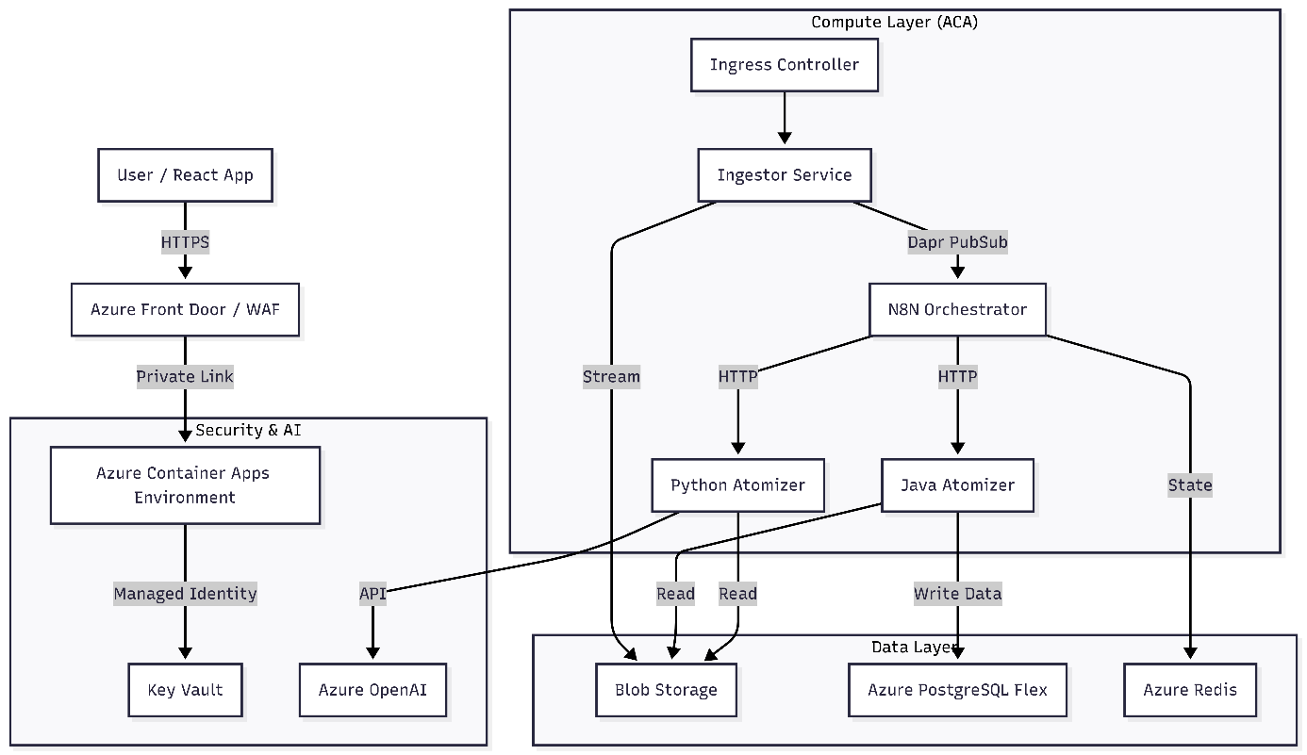

Cost estimate
Monthly cost estimate for Production environment and Dev environment
Production enviroment
Service | Configuration | Public price | GOSP price
Container Apps | 4 apps, 6 vCPU, auto-scale* | 350 Eur
PostgreSQL | Flexible, D4s_v6, 32GB SSD | 265 Eur
Redis | Balanced B5 C1 | 115 Eur
Azure Static Web Apps | Standard plan | 9 Eur
Azure Key Vault | Standard tier | 3 Eur
Blob Storage | Hot Tier, 200GB + operations | 25 Eur
App Gateway / WAF | Standard v2 | 250 Eur
Azure OpenAI | Pay-as-you-go | 100+ Eur
ElasticSearch | Optional, not need now | 100 Eur
Azure EntraID | For 50 users | 300 Eur
Azure CommServices | Pay-as-you-go | 20 Eur
Total |  | 1537 Eur
*Container Apps running cost are based on running time – 70hour/month. Azure EntraID is a default service from GOSP and we are already paying for it.
DEV enviroment
Service | Configuration | Public price | GOSP price
Container Apps | 1 apps, 6 vCPU, auto-scale* | 60 Eur
PostgreSQL | Burstable B1ms, 32GB | 15 Eur
Redis | Balanced B0 | 15 Eur
Blob Storage | Hot Tier, 20GB + operations | 5 Eur
App Gateway | Only internall access | 0 Eur
Azure OpenAI | Pay-as-you-go | 20+ Eur
Total |  | 115 Eur
*Container Apps running cost are based on running time – 70hour/month

Roadmap

Phase 0 – Generali & GOSP approval (M0)
Goal: Obtaining approval for implementation using MS Azure
Prior to commencing implementation, the necessary groundwork must be established to formally initiate a new platform initiative intended to serve a broad base of target users across the group. Preliminary assessment confirms that no comparable solution of this scope is currently deployed within the group.

Phase 1 – MVP: End-to-End ingestion (M1–2)
Goal: Prove the core data pipeline works end-to-end for a single file.
Infrastructure: Azure ACA, PostgreSQL + pgVector, Blob Storage, Traefik API Gateway/Azure API manager (APIM).
Dev: File Ingestor (streaming upload, MIME validation), PPTX Atomizer (text + table extraction), basic N8N pipeline (ingest → parse → store), Auth Service (Azure Entra ID, RBAC).
Security: ForwardAuth on API Gateway, KeyVault for secrets.
Output: User uploads a PPTX file, extracted text and tables appear in DB and basic viewer.
Note: phase 1 covers approximately 75% of the original assignment

Phase 2 – Intelligence & visualization (M3–4)
Goal: Full format support, dashboards, and data normalization. Infrastructure: N/A.
Dev: Excel Atomizer (per-sheet parsing, partial success handling), PDF/OCR Atomizer, Schema Mapping Registry (column normalization across subsidiaries), React dashboards with drill-down and period-on-period comparison, Azure OpenAI integration for data cleaning and semantic analysis.
Security: Row-Level Security in PostgreSQL (tenant isolation), ClamAV antivirus sidecar.
Output: All major file formats parsed, data normalized, holding-level dashboards live.

Phase 3 – Reporting lifecycle (M5–6)
Goal: Replace the email-Excel workflow with a managed reporting cycle. Infrastructure: N/A.
Dev: Report Lifecycle Service (state machine: Draft → Submitted → Approved/Rejected), Reporting Period Manager (deadlines, automatic form closure, escalation reminders), Form Builder – central scope (dynamic forms, Excel template export/import, validation rules, submission checklist), N8N workflows for lifecycle events (approval flow, rejection with comments, deadline notifications).
Output: Subsidiaries collect and submit OPEX data through the platform. HoldingAdmin has a real-time matrix of who delivered and what state each report is in.

Phase 4 – Report generation & production hardening (M7–8)
Goal: Close the loop from approved data to standardized output report, and prepare for production load. Infrastructure: WAF (Azure Front Door), autoscaling rules for Atomizer layer, monitoring (OpenTelemetry, Prometheus, Grafana, Loki).
Dev: PPTX Template Manager (upload central template, define placeholder mappings), PPTX Generator (automated report rendering from approved data, batch generation), Versioning & Diff Tool, Audit & Compliance Log, Notifications (SendGrid), Dead Letter Queue for failed processes.
Output: Approved data automatically generates a standardized PPTX report. Full audit trail. System is production-ready.

Phase 5 – Rollout & optimization (M9–10)
Goal: Onboard first holding companies, stabilize under real data.
Dev: MCP Server for AI agent integration, Tilt/Skaffold local dev environment, CI/CD pipeline hardening, tuning Schema Mapping learning from real column patterns.
Output: First live holding onboarded. AI-assisted data Q&A available for CFO-level users.

Phase 6 – Local scope & advanced analytics (M11+)
Goal: Extend the platform for subsidiary-level internal use and deeper period analysis.
Dev: Local Forms & PPTX Templates (subsidiaries can create their own forms and report templates for internal reporting; data can be optionally released to holding), Advanced Period Comparison (configurable KPIs, multi-org benchmarking, drill-down by cost center).
Output: Platform usable as a standalone reporting tool at the subsidiary level, not just as a holding consolidation layer.

Implementation plan

Phase 1 – MVP Core
Goal: End-to-end traversal of a single PPTX file – upload, parsing, saving, basic viewer.
Unit Area | Unit ID | Name | Tech Stack | MD | MD (AI) | Saving
MS-GW | MS-GW | API Gateway | Traefik (config) | 1 | 1 | 0
MS-CORE | MS-AUTH | Auth Service | Java 21 + Spring Boot | 30 | 9 | 21
MS-INGESTOR | MS-ING | File Ingestor | Java 21 + Spring Boot | 25 | 8 | 17
MS-INGESTOR | MS-SCAN | Security Scanner | ClamAV (sidecar) | 5 | 4 | 1
MS-PROCESSOR | MS-ATM-PPTX | PPTX Atomizer | Python + FastAPI | 35 | 16 | 19
MS-DATA | MS-SINK-TBL | Table API (Sink) | Java 21 + Spring Boot | 12 | 5 | 7
MS-DATA | MS-SINK-LOG | Log API (Sink) | Java 21 + Spring Boot | 5 | 2 | 3
MS-N8N | MS-N8N | N8N Orchestrator | N8N (JSON workflows) | 25 | 10 | 15
MS-FE | MS-FE | Frontend SPA (MD zahrnuje všechny fáze) | React 18 + Vite + TS + Tailwind | 45 | 20 | 25
Celkem |  |  |  | 183 | 75 | 108
*MS-FE only upload and viewer, but MD is for all phases
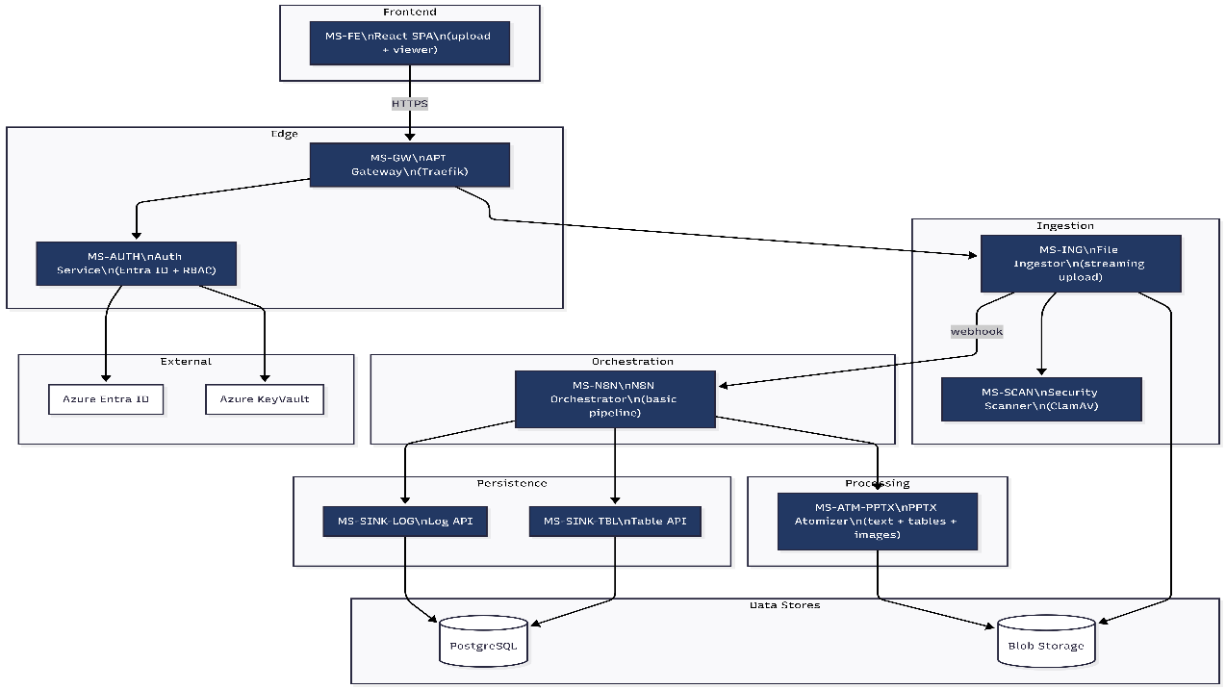

Phase 2 – Extended parsing
Goal: Full format support, RLS, Schema Mapping basics, BI dashboards.
Unit Area | Unit ID | Name | Tech Stack | MD | MD (AI) | Savings
MS-PROCESSOR | MS-ATM-XLS | Excel Atomizer | Python + FastAPI | 15 | 8 | 7
MS-PROCESSOR | MS-ATM-PDF | PDF/OCR Atomizer | Python + FastAPI | 15 | 7 | 8
MS-PROCESSOR | MS-ATM-CSV | CSV Atomizer | Python + FastAPI | 4 | 2 | 2
MS-PROCESSOR | MS-ATM-CLN | Cleanup Worker | Python (CronJob) | 5 | 3 | 2
MS-DATA | MS-QRY | Query API (Read) | Java 21 + Spring Boot | 12 | 6 | 6
MS-DATA | MS-DASH | Dashboard Aggregation | Java 21 + Spring Boot | 35 | 17 | 18
Celkem |  |  |  | 86 | 43 | 43

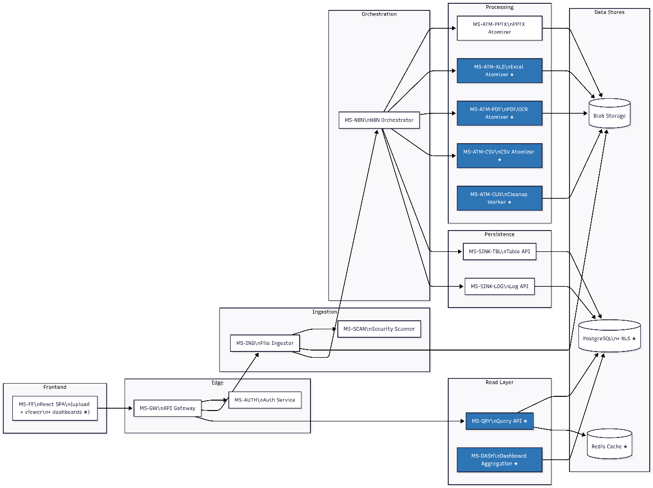

Phase 3 – Intelligence & admin
Objective: Holding hierarchy, AI integration, Schema Mapping with learning.
Unit Area | Unit ID | Name | Tech Stack | MD | MD (AI) | Savings
MS-CORE | MS-ADMIN | Admin Backend | Java 21 + Spring Boot | 20 | 12 | 8
MS-CORE | MS-BATCH | Batch & Org Service | Java 21 + Spring Boot | 15 | 8 | 7
MS-DATA | MS-TMPL | Template & Schema Registry | Java 21 + Spring Boot | 30 | 17 | 13
MS-AI | MS-ATM-AI | AI Gateway | Python + FastAPI | 3 | 2 | 1
MS-AI | MS-ATM-AI | AI P/rompting | Prompts | 10 | 8 | 2
MS-AI | MS-MCP | MCP Server (AI Agent) | Python + FastAPI | 12 | 8 | 4
Celkem |  |  |  | 90 | 55 | 35

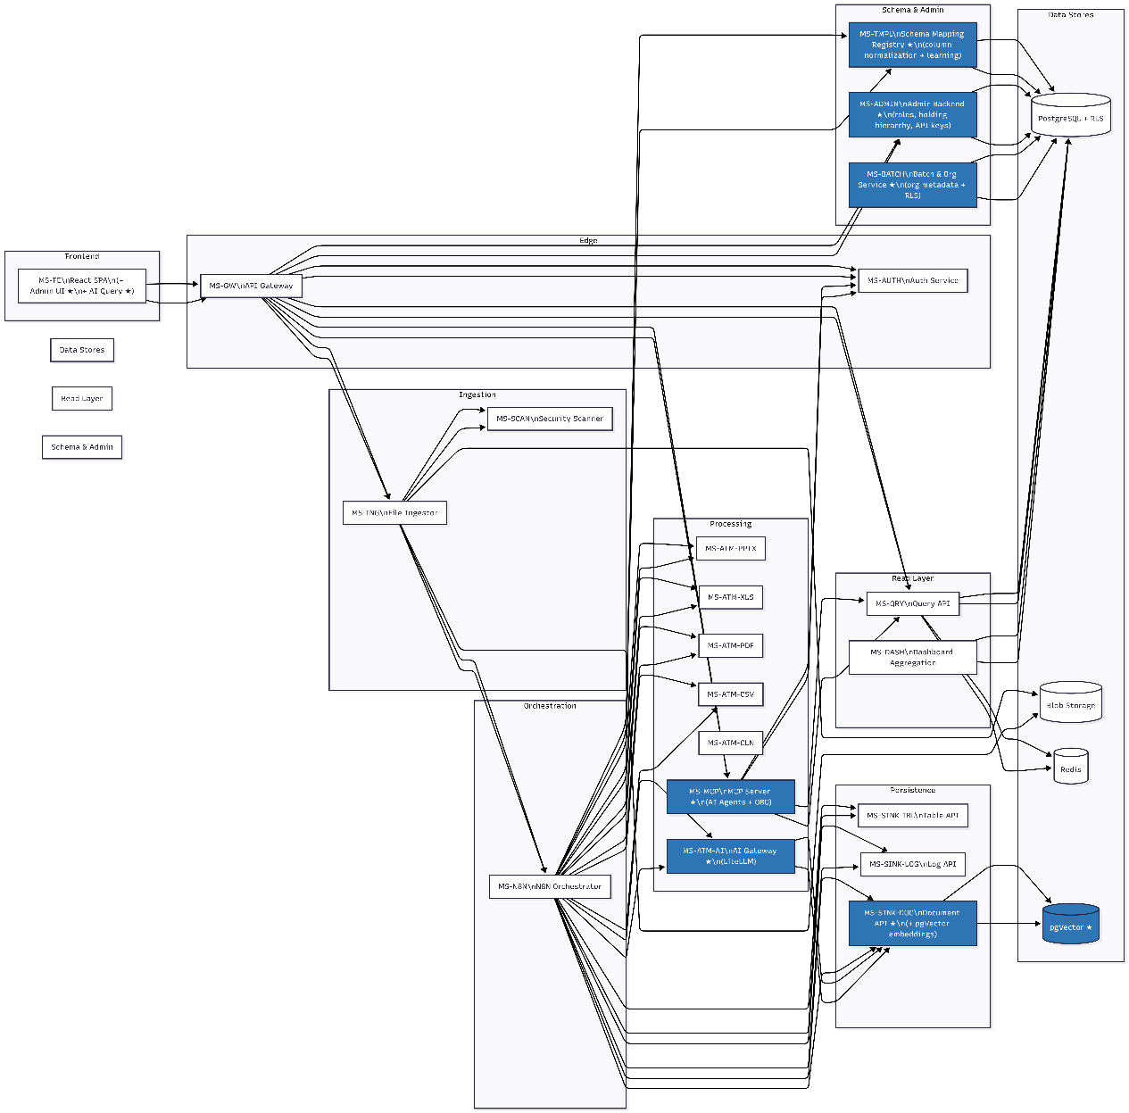

Phase 3b – Reporting lifecycle
Goal: Replace email/Excel workflow with a controlled reporting cycle with a state machine.
Unit Area | Unit ID | Name | Tech Stack | MD | MD (AI) | Savings
MS-REPORTING | MS-LIFECYCLE | Report Lifecycle Service | Java 21 + Spring Boot | 25 | 12 | 13
MS-REPORTING | MS-PERIOD | Reporting Period Manager | Java 21 + Spring Boot | 15 | 8 | 7
MS-N8N | MS-N8N (rozšíření) | N8N – Lifecycle Workflows | N8N (JSON workflows) | 15 | 12 | 3
MS-FE | MS-FE (rozšíření) | Frontend – Lifecycle UI | React | 20 | 8 | 12
Celkem |  |  |  | 75 | 40 | 35

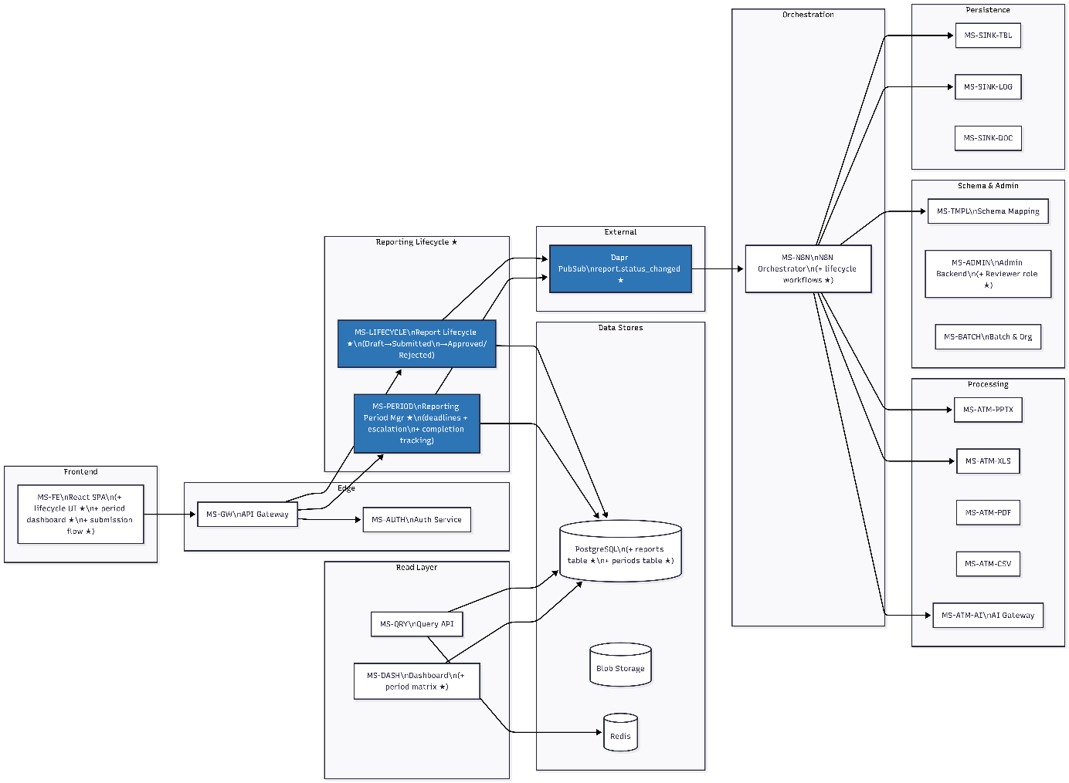

Phase 3c – Form builder
Goal: Central collection of OPEX data via forms – no more sending Excel templates by email.
Unit Area | Unit ID | Name | Tech Stack | MD | MD (AI) | Savings
MS-REPORTING | MS-FORM | Form Builder & Data Collection | Java 21 + Spring Boot | 40 | 24 | 16
MS-REPORTING | MS-FORM (Excel export/import) | Excel Template Export/Import | Java 21 + Spring Boot | 8 | 2 | 6
MS-DATA | MS-SINK-TBL (rozšíření) | Table API – form_responses | Java 21 + Spring Boot | 8 | 2 | 6
MS-FE | MS-FE (rozšíření) | Frontend – Form UI | React | 25 | 15 | 10
Celkem |  |  |  | 81 | 43 | 38

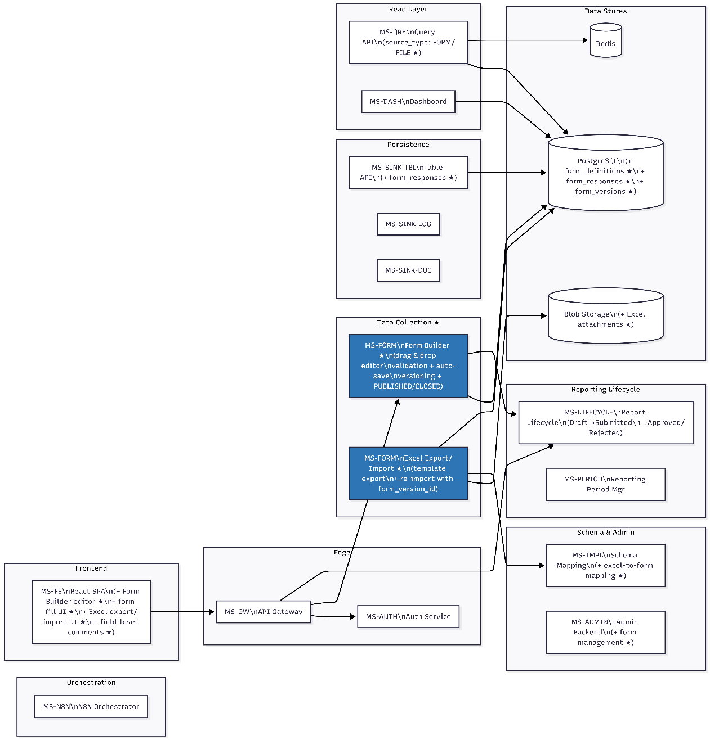

Phase 4 – Enterprise features
Goal: Compliance, versioning, notification, audit – production readiness.
Unit Area | Unit ID | Name | Tech Stack | MD | MD (AI) | Savings
MS-CORE | MS-NOTIF | Notification Center | Java 21 + Spring Boot | 15 | 8 | 7
MS-CORE | MS-VER | Versioning Service | Java 21 + Spring Boot | 16 | 7 | 9
MS-CORE | MS-AUDIT | Audit & Compliance | Java 21 + Spring Boot | 25 | 10 | 15
MS-DATA | MS-SRCH | Search Service | Java 21 + Spring Boot | 15 | 4 | 11
Celkem |  |  |  | 71 | 29 | 42

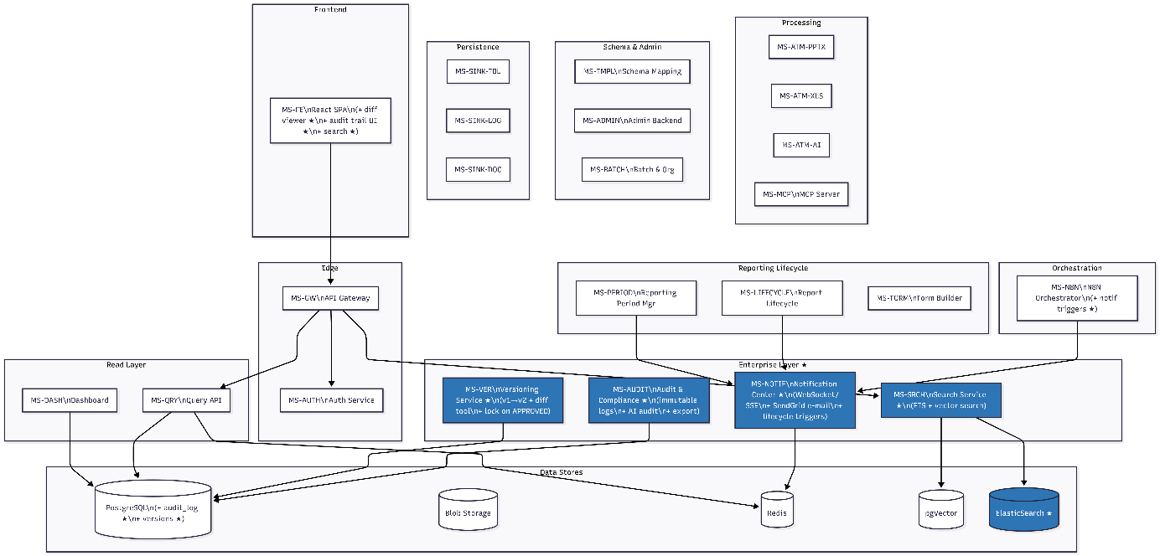

Phase 4b – PPTX report generation
Goal: Close the cycle – automatically generate a standardized PPTX report from approved data.
Unit Area | Unit ID | Name | Tech Stack | MD | MD (AI) | Savings
MS-REPORTING | MS-TMPL-PPTX | PPTX Template Manager | Java 21 + Spring Boot | 20 | 9 | 11
MS-AI | MS-GEN-PPTX | PPTX Generator | Python + FastAPI (python-pptx, matplotlib) | 32 | 16 | 16
MS-N8N | MS-N8N (rozšíření) | N8N – Generation Workflow | N8N (JSON workflows) | 8 | 6 | 2
MS-FE | MS-FE (rozšíření) | Frontend – Generator UI | React | 15 | 4 | 11
Celkem |  |  |  | 75 | 35 | 40

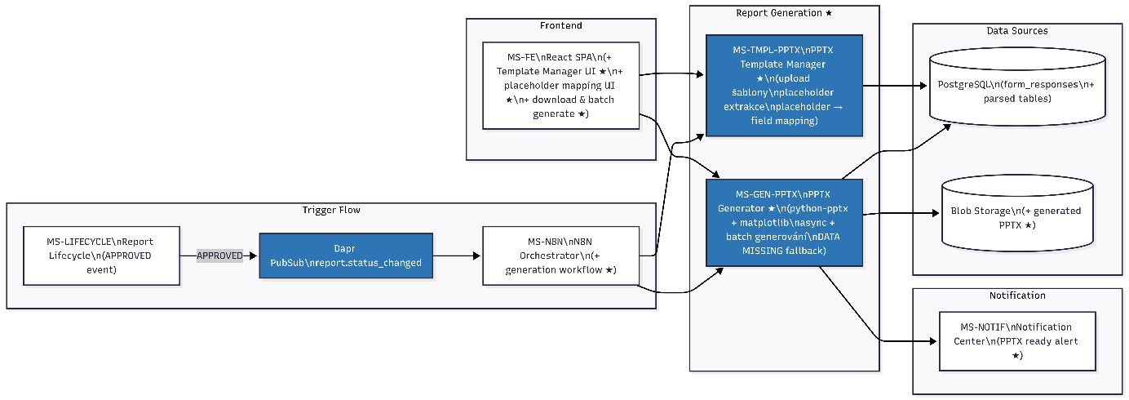

Phase 5 – DevOps maturity
Goal: Production-ready observability, CI/CD, onboarding

Oblast | Popis | MD | MD (AI) | Savings
Observability Stack | OpenTelemetry + Prometheus + Grafana + Loki | 20 | 12 | 8
CI/CD Pipelines | GitHub Actions / Azure DevOps; Native Image pipeline | 15 | 10 | 5
Local Dev | Konfigurace local devs tools | 5 | 4 | 1
First Holding Onboarding | AAD tenant, KeyVault, první perioda, Schema Mapping tuning | 10 | 10 | 0
Celkem |  | 50 | 36 | 14

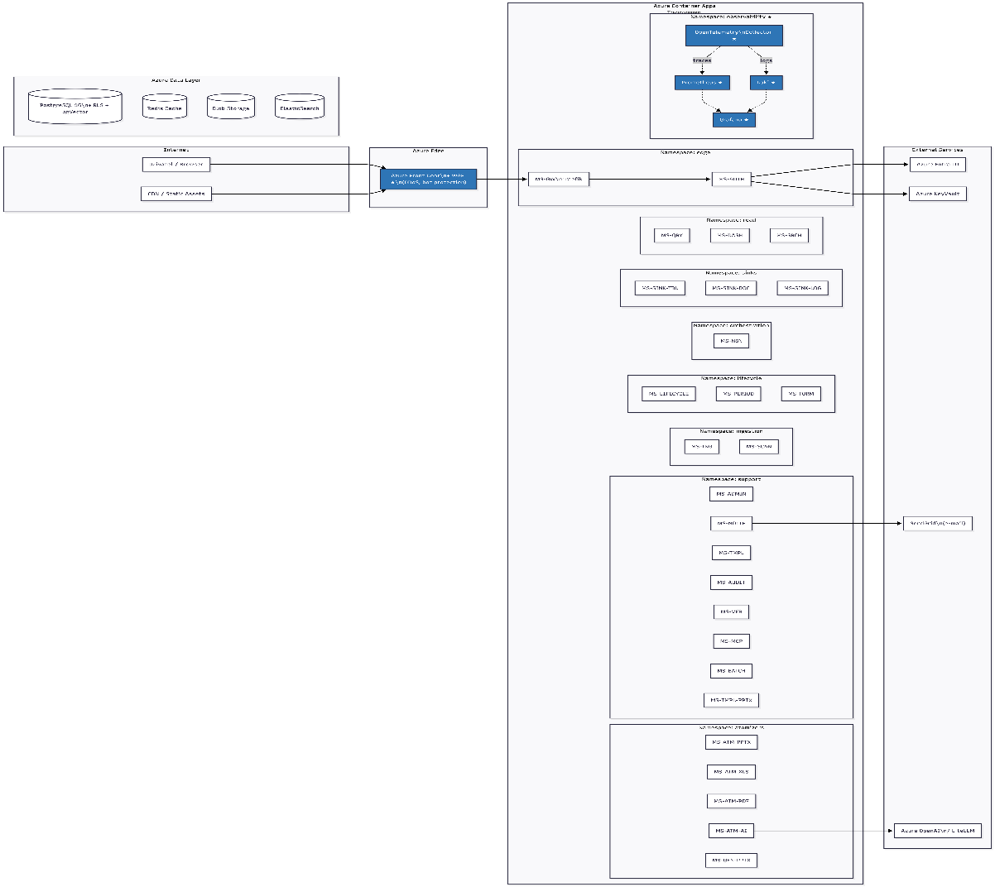

Phase 6 – Local scope & advanced analytics
Goal: Platform for internal reporting of subsidiaries; advanced period comparison.
Unit Area | Unit ID | Name | Tech Stack | MD | MD (AI) | Savings
MS-REPORTING | MS-FORM (rozšíření – FS21) | Local Forms | Java 21 + Spring Boot | 20 | 14 | 6
MS-REPORTING | MS-TMPL-PPTX (rozšíření – FS21) | Local PPTX Templates | Java 21 + Spring Boot | 15 | 8 | 7
MS-CORE | MS-ADMIN (rozšíření – FS21) | CompanyAdmin Role | Java 21 + Spring Boot | 10 | 5 | 5
MS-REPORTING | MS-PERIOD (rozšíření – FS22) | Advanced Period Comparison | Java 21 + Spring Boot | TBD | TBD | ---
MS-FE | MS-FE (rozšíření) | Frontend – Local Scope UI | React | TBD | TBD | ---
Celkem (bez TBD) |  |  |  | 45 | 27 | 18

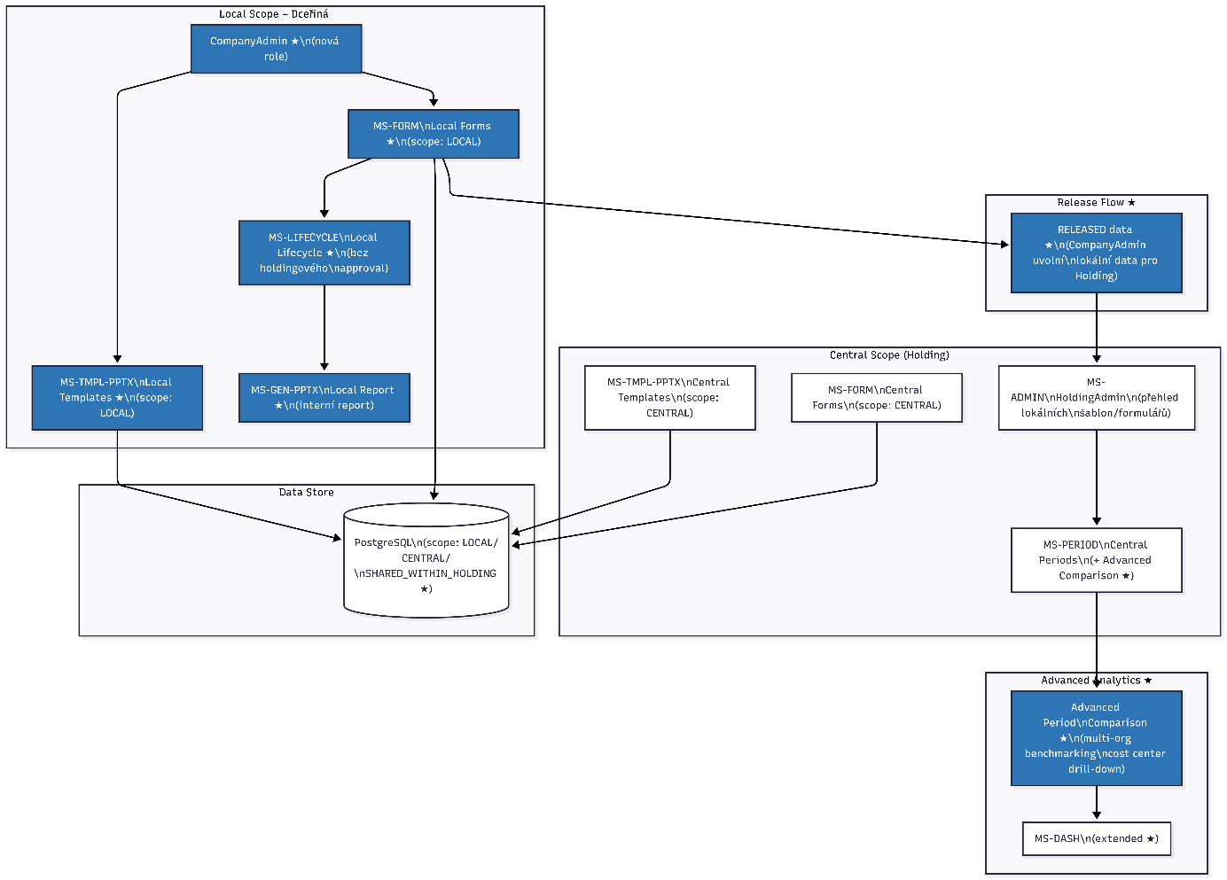

Summary
Phase | Months | MD | MD (AI) | Savings | Sav% | Key Output
Phase 1 – MVP Core | M1–2 | 183 | 75 | 108 | 59% | Upload + PPTX extrakce + viewer
Phase 2 – Extended Parsing | M3–4 | 86 | 43 | 43 | 50% | Všechny formáty + BI dashboardy
Phase 3 – Intelligence & Admin | M5–6 | 90 | 55 | 35 | 39% | AI, Schema Mapping, holdingová hierarchie
Phase 3b – Reporting Lifecycle | M6–7 | 75 | 40 | 35 | 47% | Stavový automat, periody, deadliny
Phase 3c – Form Builder | M7–8 | 81 | 43 | 38 | 47% | Centrální sběr dat, Excel export/import
Phase 4 – Enterprise Features | M8–9 | 71 | 29 | 42 | 59% | Audit, versioning, notifikace
Phase 4b – PPTX Generator | M9–10 | 75 | 35 | 40 | 53% | Automatické generování reportů
Phase 5 – DevOps & Onboarding | M10–11 | 50 | 36 | 14 | 28% | Production-ready, holding live
Phase 6 – Local Scope & Advanced | M12+ | 45 | 27 | 18 | 40% | Lokální reporting, pokročilé srovnání
CELKEM |  | 756 | 383 | 373 | 49%

Estimation Methodology and Assumptions
The man-day estimates presented in this implementation plan are derived using a standard software effort estimation methodology. Each service unit was sized based on functional complexity, number of API endpoints, data model complexity, integration dependencies, and security requirements.
Effort categories (S / M / L / XL) were applied as a sizing framework across all phases, with separate calibration for Java Spring Boot services, Python FastAPI services, N8N workflow development, and React front-end components. The resulting T-shirt size was then adjusted per unit based on a qualified review of its specific scope and content, so the final man-day figure reflects the actual estimated effort rather than a fixed category default.
The projected man-day savings from AI-assisted development (column "MD (AI)") are indicative estimates based on expected productivity gains from AI-assisted code generation, test scaffolding, and boilerplate automation. These figures assume a high-quality pre-specification — including OpenAPI contracts and data models — and implicitly account for the time required for human review and correction of AI-generated output. Actual savings will vary and will be tracked against recorded effort throughout delivery.
The total man-days in this plan represent a conservative upper bound of the estimated scope. This conservatism is intentional and reflects complexity that may be addressed more efficiently during implementation as the team gains familiarity with the platform architecture and the AI-assisted development workflow matures.
Actual delivery effort will be systematically recorded at phase completion and reported against these estimates. The resulting actuals will serve as a calibration baseline for future project estimates within the group, progressively improving forecast accuracy across similar platform initiatives.

Conclusion
The platform described in this document represents a deliberate shift from a document-centric to a lifecycle-centric approach to OPEX reporting — one that addresses not only the inefficiencies of the current process, but the structural limitations that prevent the group from scaling its financial consolidation without proportionally scaling manual effort.
The proposed architecture, phased delivery model, and AI-assisted development approach are designed to balance ambition with pragmatism. Phase 1 delivers measurable value within the first two months. Each subsequent phase builds incrementally on a stable foundation, with no phase requiring a redesign of what came before.
Successful delivery rests on a small number of critical assumptions: availability of an Azure tenant and Entra ID configuration, access to source data and subject-matter expertise from the financial controlling team during the form and schema design phases, and a stable prioritization of scope within each phase. These are not exceptional requirements — they are standard preconditions for any enterprise platform initiative of this type.
The business case is straightforward. The platform eliminates a category of manual work that currently scales with the number of subsidiaries and reporting periods. It introduces auditability, data sovereignty, and standardized output where none currently exist. And it creates a foundation that the group can extend — to internal subsidiary reporting, to AI-assisted financial analysis, to further automation — without starting over.

Final architecture

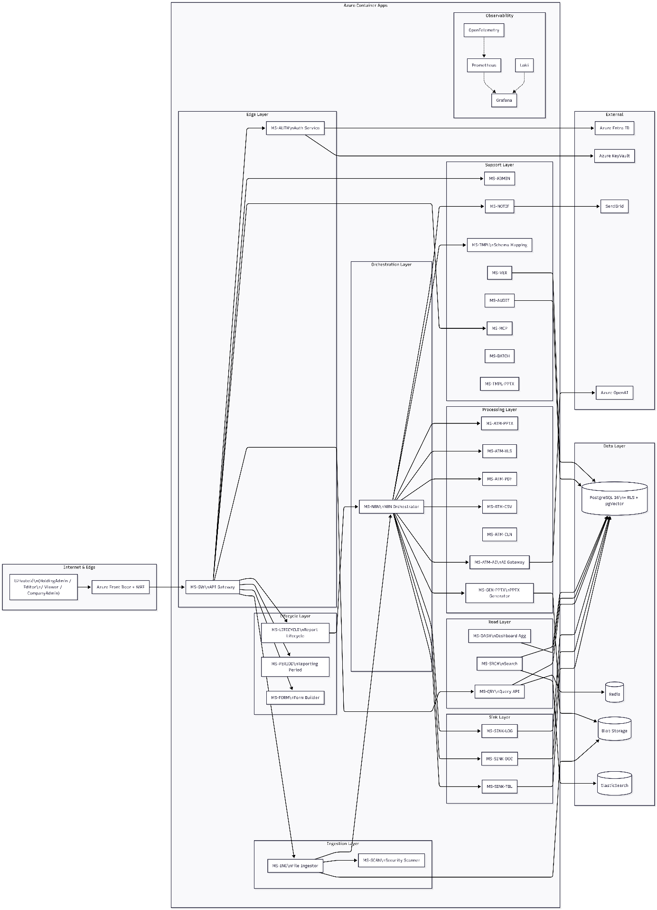

Ingestion & Processing Flow
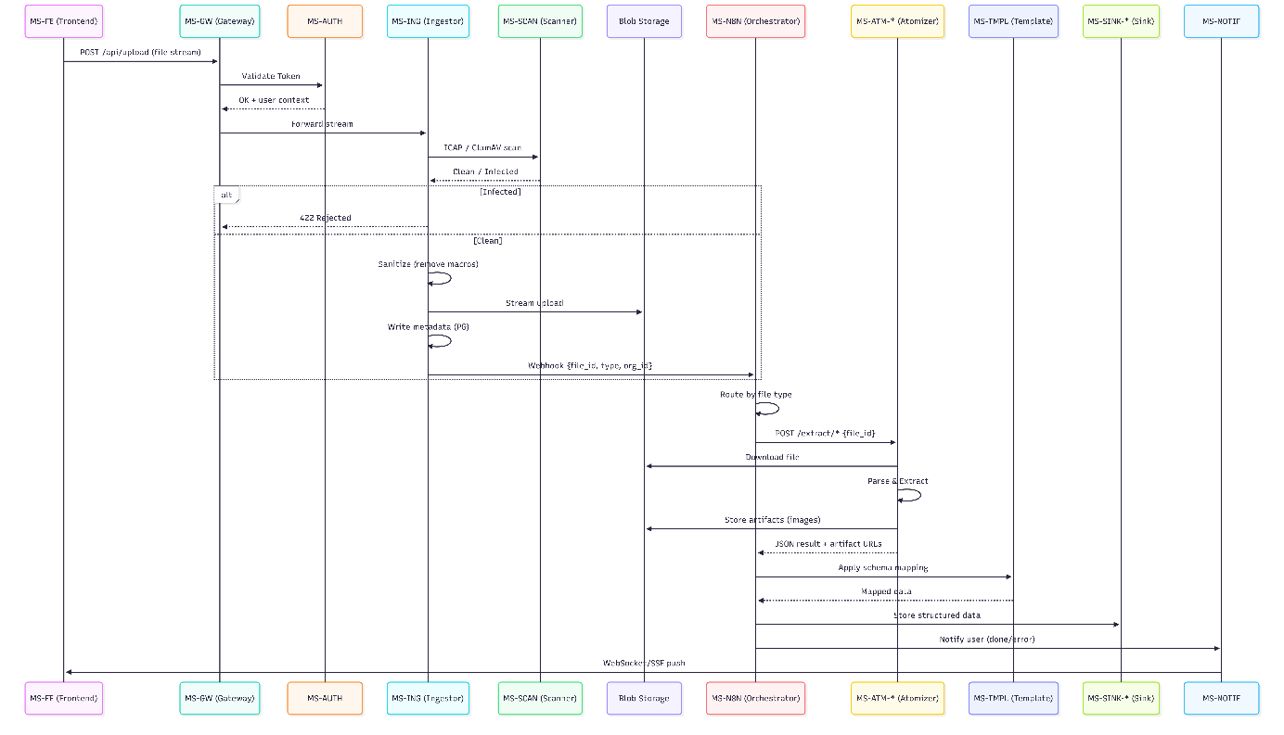

Auth & RBAC Flow
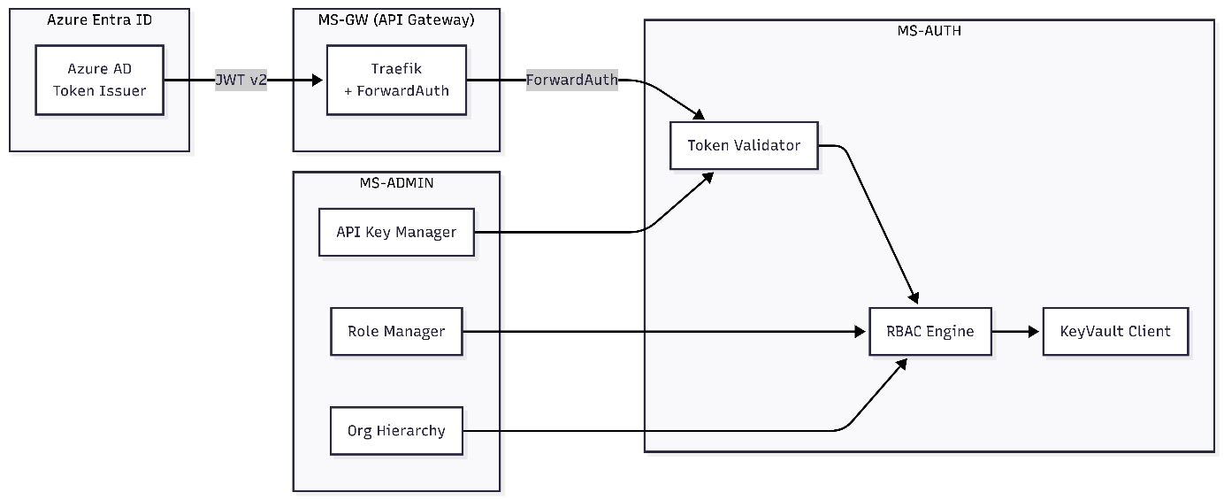

Data Persistence & Read Model (CQRS)
